
Indian Institute of Information Technology,
Nagpur

Department of Electronics and Communication Engineering

CMOS Design
(ECL-312)
3-Bit Flash ADC

Submitted To :
Dr. Paritosh Peshwe
Course Instructor

Submitted By :
Piyush Shukla
BT22ECE050

Project: Designing a 3 Bit Flash ADC.

Theory:

Analog to Digital Converter : .
A 3-bit Flash Analog-to-Digital Converter (ADC) is one of the fastest types of ADCs, known for its high-speed conversion capability. It converts an analog input signal into a 3-bit digital output by using a parallel architecture. The core components of a Flash ADC include a Voltage Divider, Comparators, and a Priority encoder.
The voltage divider generates a series of reference voltages using resistors, which are fed to the comparators. Each comparator compares the input voltage with a specific reference voltage and produces a binary output indicating whether the input is above or below the reference. The outputs of the comparators are then passed to a priority encoder, which generates the corresponding 3-bit binary code based on the highest active comparator. Due to its parallel nature, the Flash ADC offers very low latency, making it suitable for high-speed applications such as digital oscilloscopes and radar signal processing.

Key Components :

- Voltage Divider : voltage divider uses resistors to create a range of reference voltages from a single input voltage.
- Comparator : A comparator checks if the input voltage is higher or lower than a given reference voltage and outputs high or low.
- Priority Encoder : A priority encoder converts multiple comparator outputs into a binary number, selecting the highest active input line first.
Fig(1).
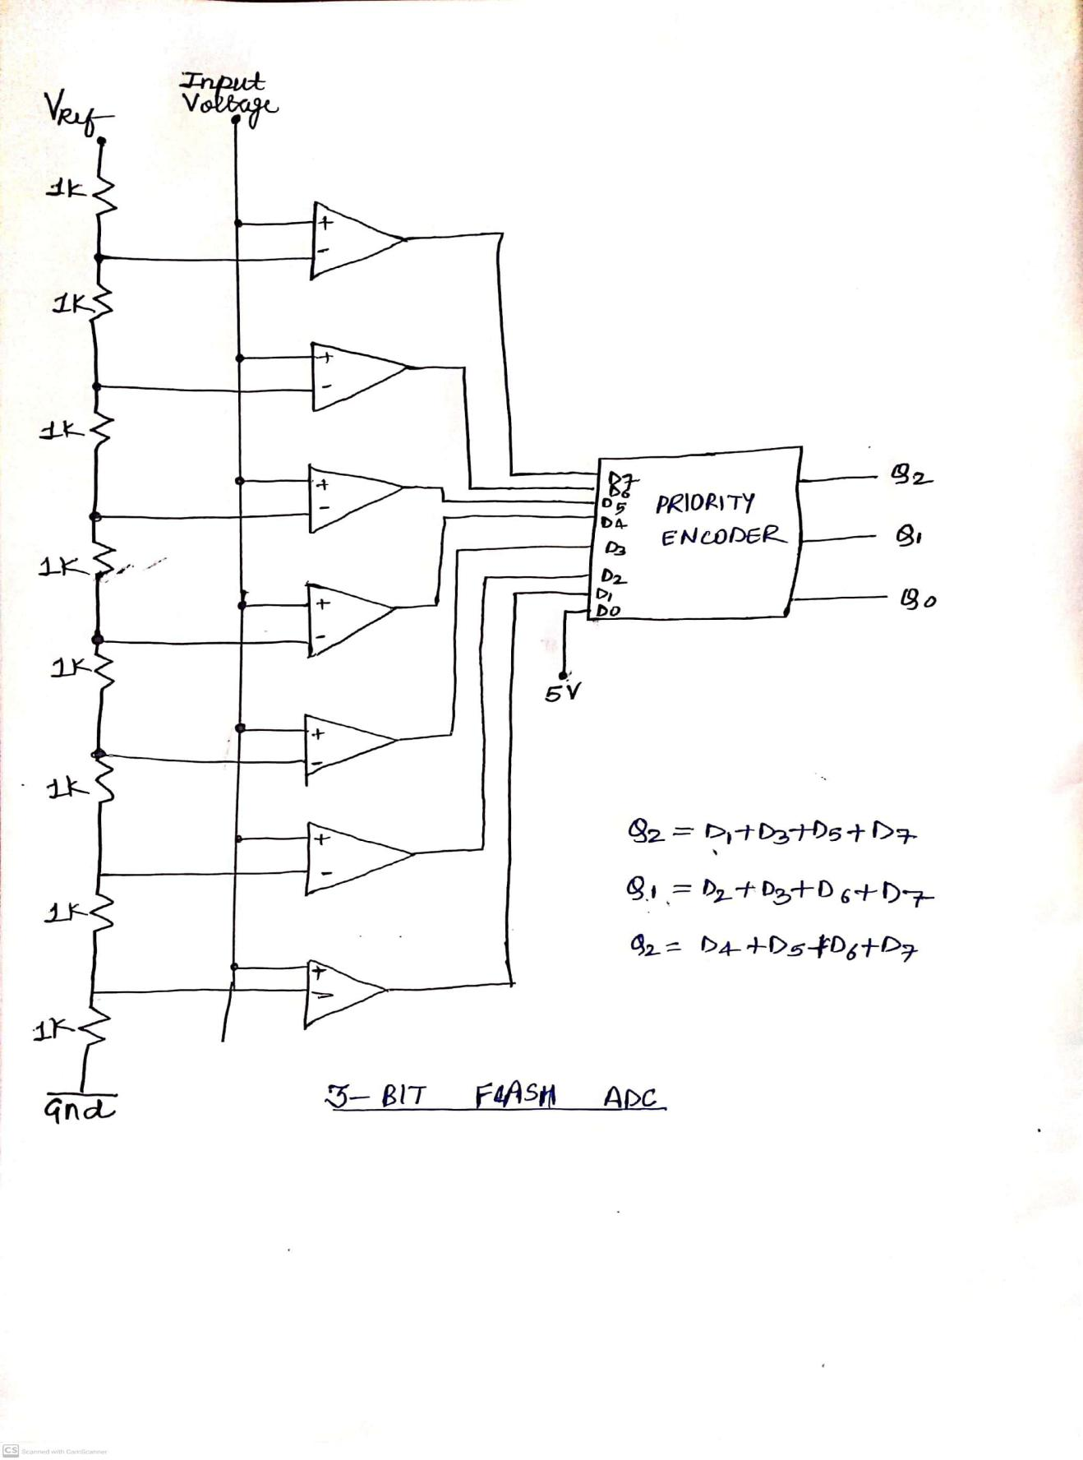
Schematic Diagram of 3-Bit Flash ADC

Netlists and Outputs:

Figure 2: MOSFET Structure of Comparator
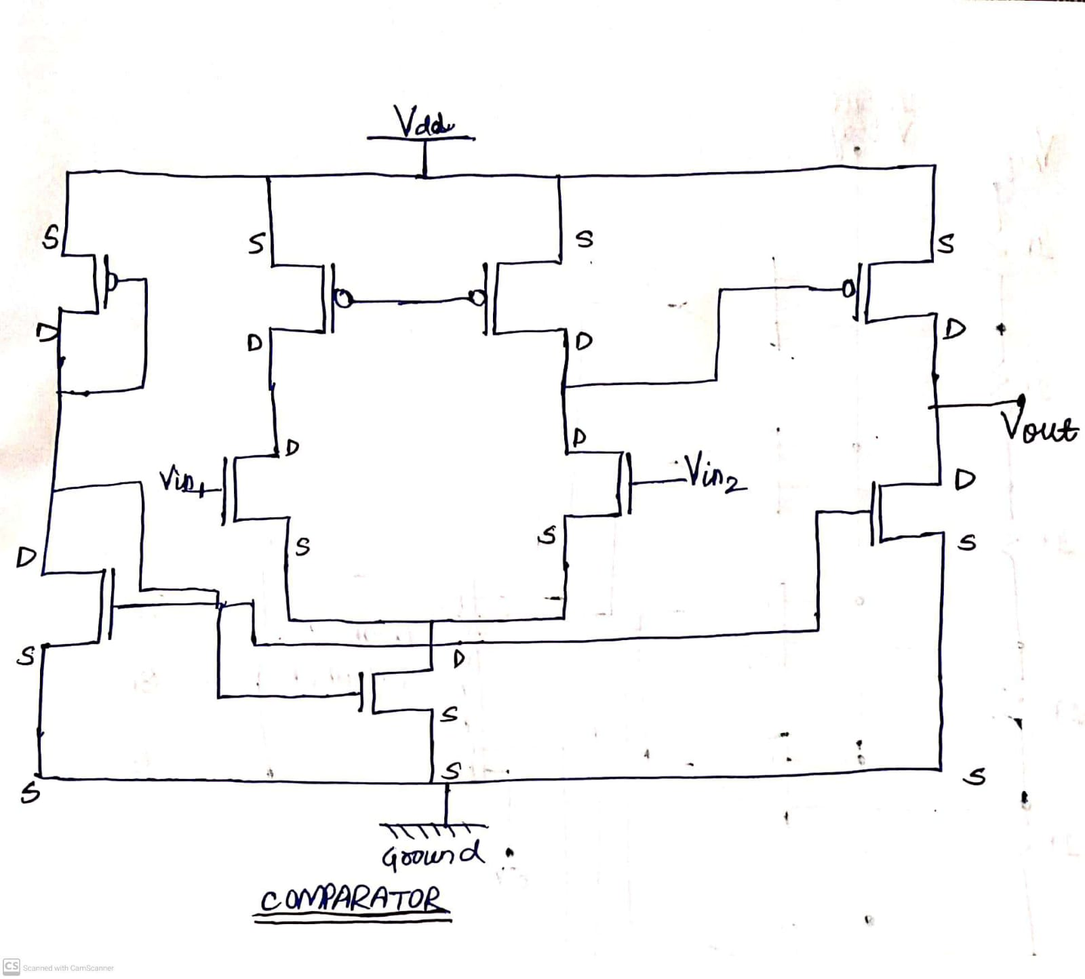

Netlist of ADC

- *** adc***

- VDD 1 0 DC 8V
- V1 106 0 DC 1.80V
- V2 107 0 DC 1.80V
- V3 108 0 DC 1.80V
- V4 109 0 DC 1.80V
- V5 110 0 DC 1.80V
- V6 111 0 DC 1.80V
- V7 116 0 DC 1.80V
- Vref 121 0 DC 8V

R1 112 121 1000
R2 119 113 1000
R3 118 114 1000
R4 113 115 1000
R5 0 117 1000
R6 114 119 1 00
R7 115 112 1000
R8 117 118 1000

MN1 45 55 0 0 N1 w=10u l=1u
MN2 0 57 42 0 N1 w=10u l=1u
MN3 43 61 0 0 N1 w=10u l=1u
MN4 42 56 0 0 N1 w=10u l=1u
MN5 0 45 39 0 N1 w=10u l=1u
MN6 0 43 37 0 N1 w=10u l=1u
MN7 0 42 36 0 N1 w=10u l=1u
MN8 0 57 43 0 N1 w=10u l=1u
MN9 42 54 0 0 N1 w=10u l=1u
MN10 0 54 45 0 N1 w=10u l=1u
MN11 43 65 0 0 N1 w=10u l=1u
MN12 0 65 42 0 N1 w=10u l=1u
MN13 45 59 0 0 N1 w=10u l=1u
MN14 0 59 43 0 N1 w=10u l=1u
MN15 0 65 45 0 N1 w=10u l=1u
MN16 0 82 54 0 N1 w=10u l=1u
MN17 0 83 55 0 N1 w=10u l=1u
MN18 0 84 56 0 N1 w=10u l=1u
MN19 0 85 57 0 N1 w=10u l=1u
MN20 0 86 59 0 N1 w=10u l=1u
MN21 0 87 61 0 N1 w=10u l=1u
MN22 0 88 65 0 N1 w=10u l=1u
MN23 99 108 68 0 N1 w=10u l=1u
MN24 100 116 69 0 N1 w=10u l=1u
MN25 101 111 70 0 N1 w=10u l=1u
MN26 102 109 71 0 N1 w=10u l=1u
MN27 103 107 72 0 N1 w=10u l=1u
MN28 104 110 73 0 N1 w=10u l=1u
MN29 105 106 74 0 N1 w=10u l=1u
MN30 0 82 99 0 N1 w=10u l=1u
MN31 0 83 100 0 N1 w=10u l=1u
MN32 0 84 101 0 N1 w=10u l=1u
MN33 0 85 102 0 N1 w=10u l=1u
MN34 0 86 103 0 N1 w=10u l=1u
MN35 0 87 104 0 N1 w=10u l=1u
MN36 0 88 105 0 N1 w=10u l=1u
MN37 99 113 75 0 N1 w=10u l=1u
MN38 100 119 76 0 N1 w=10u l=1u
MN39 101 117 77 0 N1 w=10u l=1u
MN40 102 114 78 0 N1 w=10u l=1u
MN41 103 115 79 0 N1 w=10u l=1u
MN42 104 118 80 0 N1 w=10u l=1u
MN43 105 112 81 0 N1 w=10u l=1u
MN44 0 82 82 0 N1 w=10u l=1u
MN45 0 83 83 0 N1 w=10u l=1u
MN46 0 84 84 0 N1 w=10u l=1u
MN47 0 85 85 0 N1 w=10u l=1u
MN48 0 86 86 0 N1 w=10u l=1u
MN49 0 87 87 0 N1 w=10u l=1u
MN50 0 88 88 0 N1 w=10u l=1u

MP1 1 42 36 1 P1 w=10u l=1u
MP2 1 43 37 1 P1 w=10u l=1u
MP3 1 45 39 1 P1 w=10u l=1u
MP4 44 56 42 1 P1 w=10u l=1u
MP5 46 61 43 1 P1 w=10u l=1u
MP6 47 57 44 1 P1 w=10u l=1u
MP7 48 55 45 1 P1 w=10u l=1u
MP8 49 57 46 1 P1 w=10u l=1u
MP9 50 54 47 1 P1 w=10u l=1u
MP10 51 54 48 1 P1 w=10u l=1u
MP11 52 65 49 1 P1 w=10u l=1u
MP12 1 65 50 1 P1 w=10u l=1u
MP13 53 59 51 1 P1 w=10u l=1u
MP14 1 59 52 1 P1 w=10u l=1u
MP15 1 65 53 1 P1 w=10u l=1u
MP16 1 68 54 1 P1 w=10u l=1u
MP17 1 69 55 1 P1 w=10u l=1u
MP18 1 70 56 1 P1 w=10u l=1u
MP19 1 71 57 1 P1 w=10u l=1u
MP20 1 72 59 1 P1 w=10u l=1u
MP21 1 73 61 1 P1 w=10u l=1u
MP22 1 74 65 1 P1 w=10u l=1u
MP23 1 75 68 1 P1 w=10u l=1u
MP24 1 76 69 1 P1 w=10u l=1u
MP25 1 77 70 1 P1 w=10u l=1u
MP26 1 78 71 1 P1 w=10u l=1u
MP27 1 79 72 1 P1 w=10u l=1u
MP28 1 80 73 1 P1 w=10u l=1u
MP29 1 81 74 1 P1 w=10u l=1u
MP30 1 75 75 1 P1 w=10u l=1u
MP31 1 76 76 1 P1 w=10u l=1u
MP32 1 77 77 1 P1 w=10u l=1u
MP33 1 78 78 1 P1 w=10u l=1u
MP34 1 79 79 1 P1 w=10u l=1u
MP35 1 80 80 1 P1 w=10u l=1u
MP36 1 81 81 1 P1 w=10u l=1u
MP37 1 82 82 1 P1 w=10u l=1u
MP38 1 83 83 1 P1 w=10u l=1u
MP39 1 84 84 1 P1 w=10u l=1u
MP40 1 85 85 1 P1 w=10u l=1u
MP41 1 86 86 1 P1 w=10u l=1u
MP42 1 87 87 1 P1 w=10u l=1u
MP43 1 88 88 1 P1 w=10u l=1u

.model N1 NMOS LEVEL=54 version=4.7
.model P1 PMOS LEVEL=54 version=4.7

.tran 0.1 320
.control
run
plot V(39) V(37) V(56)
.endc
.END

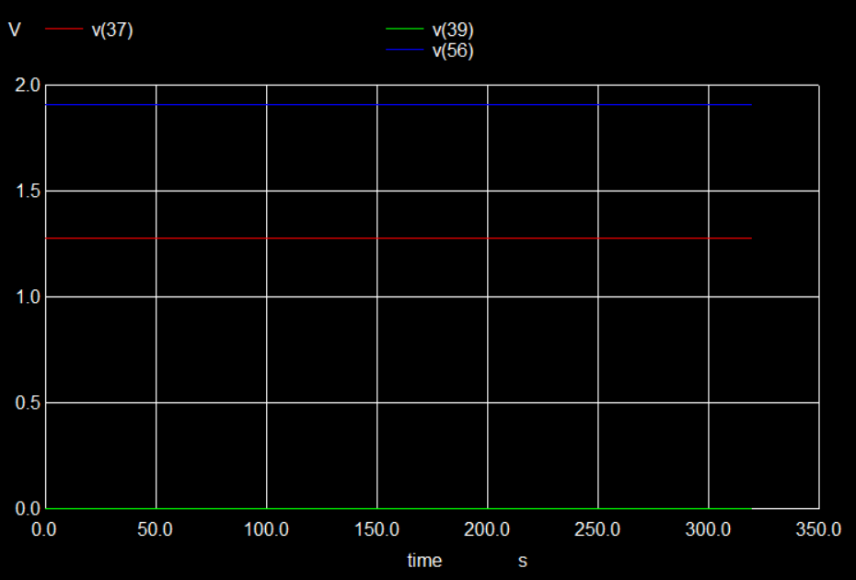

Output of ADC Netlist

3 BIT FLASH ADC LAYOUT
Figure 8: Comparator
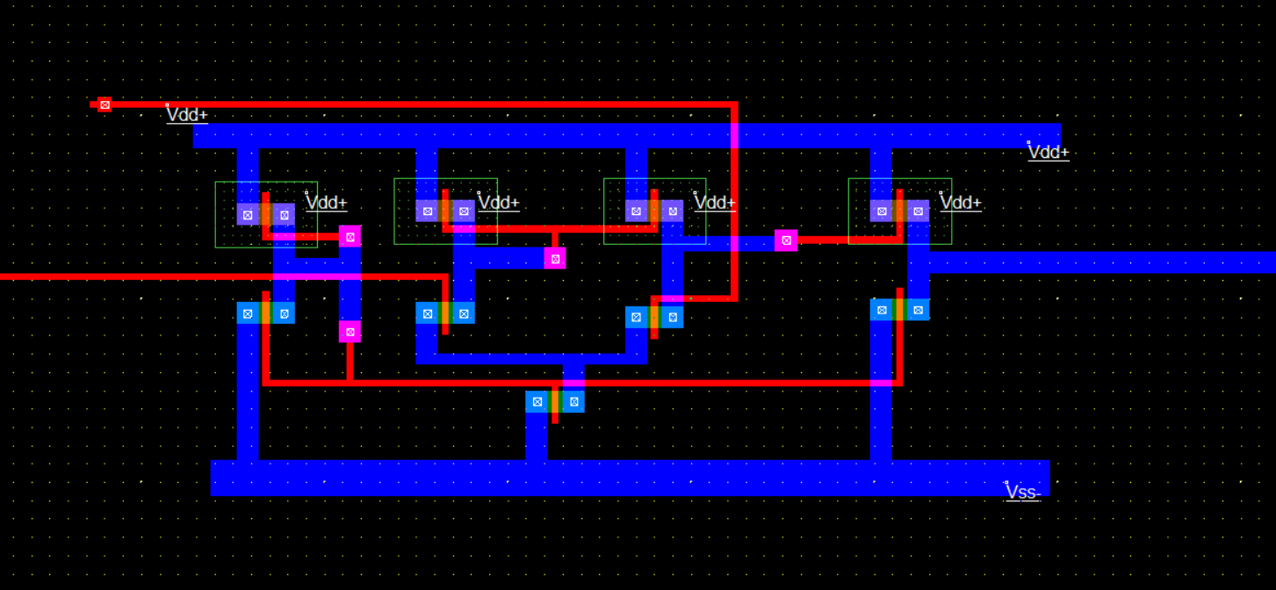

There are 7 comparators in the circuit. Each comparator has two inputs one from the voltage divider and one analog input from the user. The output of each comparator is a bit, which goes as input to the priority encoder.

Figure 9: Priority Encoder
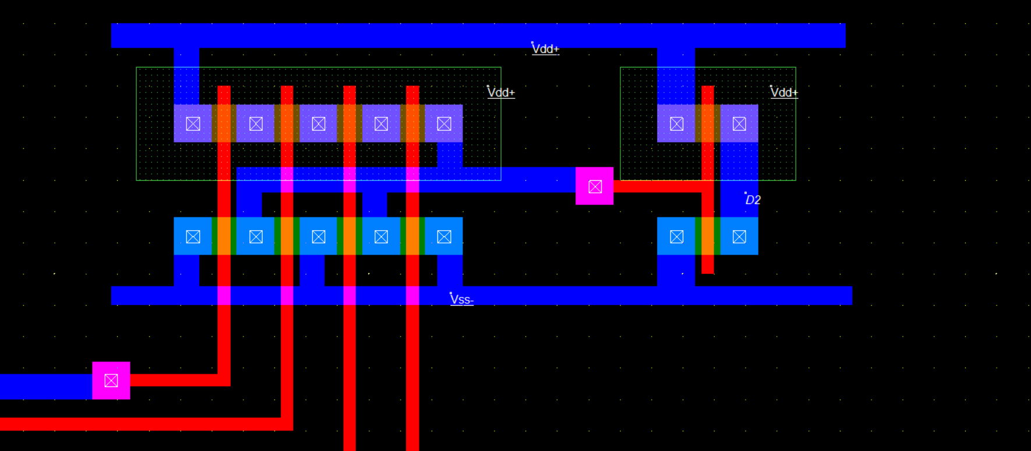
The above figure is a Priority Encoder of 3 bits where it has 8 Inputs, 7 from the Compators and one given as 5V and has 3 bit Digital Output. It has been made using 4 Input OR gate by solving the K-Map and getting Equation.
- Bit Flash Analog to Digital Converter

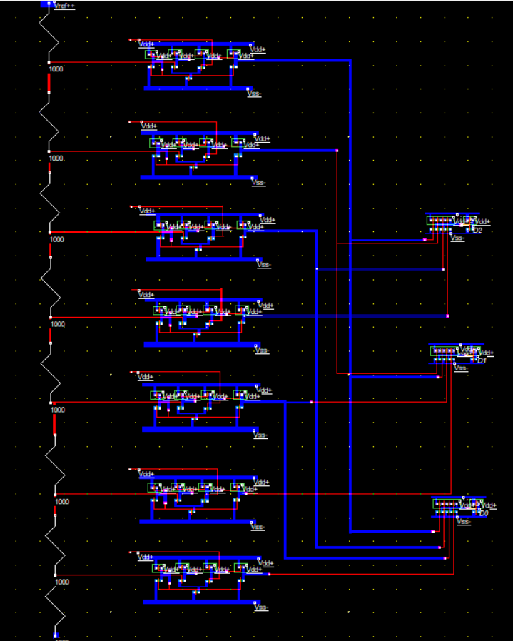

Figure 11: DC Generation Circuit Output
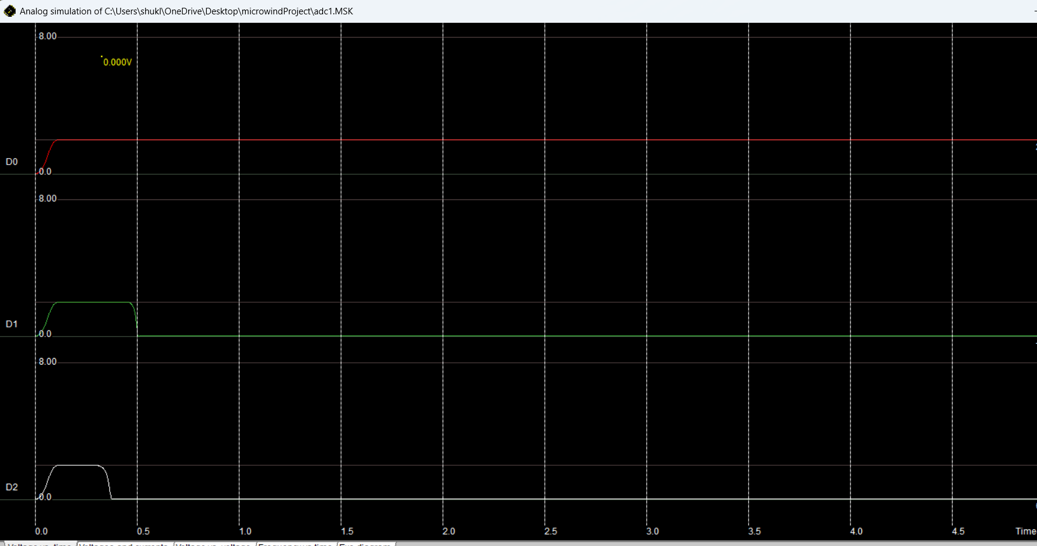
This the Output of the ADC when the given Input was Vin = 1.800V (Analog Value), then the Output comes as 001.

Conclusion:
In conclusion, the 3-bit Flash ADC was successfully designed with a CMOS layout using Microwind software. The netlist code was written to describe the circuit, and the output waveforms were obtained and analyzed. This confirmed the proper working of the design and its components like Voltage Divider, Comparators and Priority Encoder.

